**Purpose of the experiment:**

The purpose of this lab is to use Euler’s method to determine the behavior of a ball in different conditions. We will examine the ball in motion with no wind flow and no magnus force; with tail wind and no magnus force; with head wind and no magnus force; and with no wind flow and a magnus force that is present. Drag force is present in all situations

**Problem Description:**

In lab 3, we are given the drag force. The drag force is a force opposing the motion of an object, and in this case, the ball, with respect to the surrounding fluid. This is sometimes called fluid resistance and or fluid friction.

*(Equation (1) – the Drag Force where B_2 is the drag coefficient and v is the velocity of the ball)*

It is also known that that the drag coefficient is the function of velocity itself. The equation for the drag coefficient is described below.



*(Equation (2) – drag coefficient where v is velocity, v_d is 35 m/s and the delta symbol represents 5 m/s, and m is mass)*

I then wrote a python script solving for the differential equations below:



*(Equation (3) – velocity in the x direction)*



*(Equation (4) – velocity in the y direction)*



*(Equation (5) – drag force described in x direction, v is velocity, and m is mass)*



*(Equation (6) - drag force described in y direction, where g is gravity, v is velocity, and m is mass)*

The next part of the graph includes the head and tail winds which changed the drag force to equation (7) and (8).



*(Equation (7) – new drag force in the x direction. It’s the same as equation (5) except it v_w is subtracted from v and v_x where v_w is the velocity from the wind)*



*(Equation (8) – although there is a new vector describing the motion of the ball due to wind resistance, it is mostly affected in the x direction and not y direction, so it is subtracted only from v)*

I then modified my python script so that instead of the script to include v_wind for the equations that described the drag force. I then used a head and tail wind of 4.5 m/s to calculate the behavior of the graph.

For the second part of the lab, I graphed the behavior of the ball without any wind. The magnus force is a force that is observed as curving away from its principal flight path. Equation (9) below describes the magnus force.



*(Figure (9) – Magnus force. S_0/m is the coefficient equivalent to 4.1 * 10 ^-4 and m is the mass of the ball of 149 grams)*

To calculate the trajectory of the ball with magnus force, the y component of the velocity in the script and negligible drag force in the y and z directions described by the equations below.



*(Equation (10) – velocity in the z direction)*



*(Equation (11) – gravity affecting the motion of the ball in the y direction)*



*(Equation (12) – the magnus force affecting the trajectory of the ball in the z direction)*

After the modifications, I then graphed my results and analyzed the results

**Code:**

In the beginning of my code, I imported useful functions numpy and and matplotlib.pyplot for mathematical and plotting uses. I then declared the initial values for to find the trajectory of the ball excluding the values and constants needed for magnus.

t, dt = 10.0, 0.01

theta = 35.0*(np.pi/180)

n = int(t/dt)

gravity = 9.81

mass = 1

v_x = 50*np.cos(th0)

v_y = 50*np.sin(th0)*np.cos(phi)

v_z = 50*np.sin(th0)*np.sin(phi)

*(Figure (1) – These are my initializing statements for the whole script)*

t holds the value of 10, which is the time length we will examine the behavior of the ball for, and dt is the number of steps. mass is mass of the ball in kilograms. n represents the number of points that will be plotted and g represents gravity in m/s^2. Then the x, y, z components of the velocity were initialized. v_x is x component, v_y is the y component of the velocity, and z is the z component of velocity.

def calc_2d(velx, vely, velz, v_resitance, YY):

x = np.zeros(n); y = np.zeros(n); z = np.zeros(n)

x[0] = 0; y[0] = YY; z[0] = 0

vd, delta = 35.0, 5.0

w = 2*(np.pi)*30

t = 0;

S0 = (4.1e-4)*m

FOR LOOP HERE

*(Figure (2) – The initial values in calc_2d)*

I then created my function calc_F similarly to figure (2) to create a graph and calculate the values that would be needed to graph my results. In my function, I passed the variables velx, vely, velz , v_resistance, and YY as arguments. v_resistance passed the values for head and tail winds. velx, vely, velz are the components of velocity. YY is the initial value of y that would be passed since Y has a different initial value when calculating the trajectory with the magnus force in this lab. x, y, and z would hold the arrays for the distances that I would graph and are initialized. x, y and z represented equations (3), (4), (12) respectively. The other constants are then initialized. vd represents v_d from equation (2) and delta represents delta symbol from equation 2 also. W is the angular momentum that would be used for calculating the effects of the magnus force and t was initialized as a local variable to zero since t represented time. S0 represents the magnus coefficient

FOR LOOP HERE is where I have a for loop that is used to execute the calculations for the x and y values which will be described in figure (3).

for i in range(n-1):

v_mag = (np.sqrt((velx-v_resitance)**2 + vely**2 + velz**2))

B2 = (0.0039 + (0.0058/(1 + np.exp((v_mag-vd)/delta))))*m

velx = velx - (B2/m) * v_mag * (velx-v_resitance) * dt

velz = velz - (S0/m) * w * velx * dt

if (velz > 0):

vely = vely - g*dt

else:

vely = vely - g * dt - (B2/m) * v_mag * vely * dt

x[i+1] = x[i] + velx*dt

y[i+1] = y[i] + vely*dt

z[i+1] = z[i] + velz*dt

t = t + dt

fly = [x,y,z]

return(fly)

*(Figure (3) – the FOR LOOP HERE statements from figure (2) this is where the calculations were done and executed in function calc_F)*

In this for loop I calculated v_mag which represent v ins equations 5, 6, and 7 and was the magnitude of the velocity. Inside v_mag, I had v_resistance subtracted from v_x. Some parts of the lab didn’t have any head or tail winds. This was okay since I would just pass 0.0 for v_resistance as an argument. I then Initialized B2 to represent the coefficient of drag. Velx inside the for loop represented equation (5) or equation (7) depending on what was passed for resistance, vely represented equation (6) or equation (8) if we weren’t calculating the magnus force. If magnus force was being calculated then I had an if – then statement to detect that by detecting when I passed v_z to be greater than zero since v_z was passed as zero when the function wasn’t being used to calculate magnus force. So magnus force was being calculated, I had vely to describe equation (11). Velz described equation (12)

I then stored all the values at each iteration into x y and z and stored them into fly. I then returned fly.

def plot2d(y, tl, zbegin, xlim, ylim):

plt.xlabel('Distance (m)')

plt.ylabel(y)

plt.xlim([0,xlim])

plt.ylim([zbegin,ylim])

plt.legend()

plt.title(tl)

*(Figure (4) – plot2d function I use to plot my values)*

I have a plot2d function that I used to graph my results since it would have been repetitive to hard code for plotting. For the function I passed label names for the vertical axis (y),the x limits (xlim), y limits (ylim) and z limits (zlim) and also a plot title(tl).

#Initialize constants and title names

#Block of codes#

#initialized more constants depending what needed to be calculated

#call calc_f function and assign it

#plot the results

#call the function plot2d() to set parameters and pass the constants and titles declared before

…(Repeat blocks of codes until everything has been graphed)…

*(Figure (5) – structure of my function calls and plotting in ‘main’ portion)*

I also have a “main portion” of the lab that does all the function calls and some changes to the variables v0 th0 y0 and m. For the magnus function. Some the variables were holders for strings that would be passed to function plot2d. Figure (5) shows the structure of my ‘main’ portion of the script. In the script, v_tail represents tail wind and v_head represents head wind.

**Equations Solved & Algorithms Used:**

In this lab, I solved for the equations 3 – 8 and 10 – 12. Even though the lab presented itself in vector form that was a 2nd order differential equation, it was solved via Euler’s method. To use Euler’s method, I split the all the vectors into their x, y, and z position and direction components. This would help me solve for the equations and graph them in my python script.

When graphing equation 5 and 6, I would use my python script to first calculate the y value at certain x value and then go to next increment which was (x + dt) where dt = .01. Then I would then calculate and plot the new y value at (x + dt). I would keep doing this in my script, in particular my for loop in figure (3) until I reached the max x-value that was asked of me to graph and calculate. I would do something like this when solving for other equations such as equation (7), (8), (10), (11), (12) to help me graph my results through my python script.

**Results & Analysis**

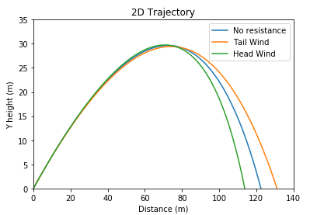

*(Figure (6) - Graph of Head wind vs tail wind vs no resistance)*

The green and orange lines in figure (6) are described by equations (7) and (8) when there is any type of resistance or wind to affect the motion of the ball at all. The wind will affect the vector of the ball but mostly in the x – direction since its biggest impact is on the x-component. Hence the differences in equation (8) with equation (7) and with equation (1). The wind affects maximum range of the ball depending on the direction of the wind. Since the tail wind (orange line) is moving in the same direction of the ball it will travel a further distance in x – direction than the trajectory with head wind or no resistance. The head wind will move against the ball in the x – direction, thus the ball will travel the least amount of distance in the x – direction. The graph of the baseball unaffected by wind is useful for me to compare the different effects wind has on the motion of the ball.

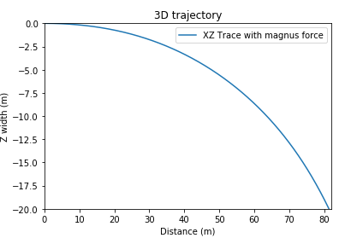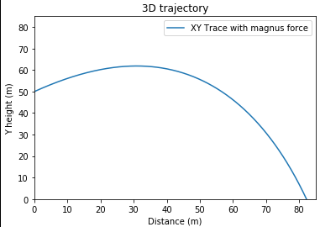*(Figure (8) & (9) – The right (9) describes the XZ trace of the magnus force and the left (8) describes the XZ trace of the magnus force)*

Figure (9) the ball travel in the -z direction because of the magnus force acted on it. It had traveled 20 meters in the negative z direction because of the baseball spinning at 30 rev/s. Figure 8 describes the new trajectory of the ball in the XY plane with decreased initial speed but with an initial height of 50 meters in the Y direction. It does not travel as far in the x direction as any of the lines from figure (6) despite its initial height.